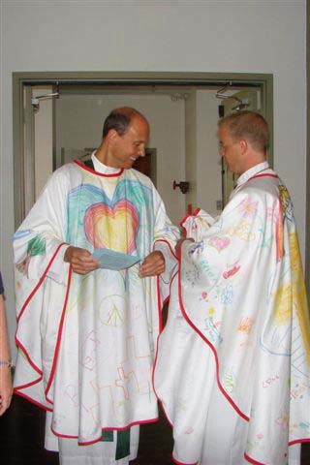
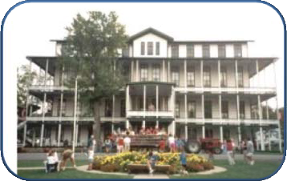
CAMP TRINITY

September 22-24, 2017
Shrine Mont, Orkney Springs, VA

“All Are Welcome”

Please join your fellow Holy Trinity Parishioners in a beloved thirty year tradition! Camp Trinity is a weekend of enriching our faith through ‐‐ activity and quiet, solitude and fellowship, prayer and games, meeting old friends and making many new ones‐‐ in a stunningly beautiful setting. Programs are designed for those of all ages and from all walks of life: the weekend is richer with a diverse community participating. The weekend is open to all parishioners, and is a great way to connect in a deeper way with fellow parishioners. Consider being a part of it!

What Activities Can I Participate in? It’s Up to You!

Hayride * Bingo *Kids Reading Time * Children’s Parade * Morning Prayer * Capture the Flag * Hiking * Community Meals * Sing Along * Teen Hike * Quiet Reflection * Hunting for Salamanders * Tennis * Fishing*Dynamic Speakers
* Programs for all ages including dynamic adult speakers* Reading * Bingo* Conversation *Adult
Happy Hour * Grotto Prayer & Healing Service *Labyrinth* Family Time * Sunday Mass * Meeting New Friends!

What Is the Cost?
AGE GROUP | RATE
Adults & grades 9-12 | Double occupancy $197
Adults & grades 9-12 | Single occupancy $247
PreK- 8th | $70
0-3 yrs | $15
**Saturday Only**-includes 2 meals | $50
**Please note the teen rate may change if there is a teen retreat**

Registration includes lodging, all meals, and activities. The parish does not want cost to be a barrier to any parishioner wishing to attend, therefore discounted rates and scholarships are available by contacting Lisa Dittmeier at ldittmeier@trinity.org Payments are made using Holy Trinity’s online giving portal.

Visit the Camp Trinity website to register: www.trinity.org/parishlife/camptrinity. Questions? Contact a member of the Camp Trinity 2017 Planning Team Steering Committee @ CampTrinity@Trinity.org.

Keep Your Eyes on The Bulletin for upcoming Fun activities with your Camp Trinity Family!!

