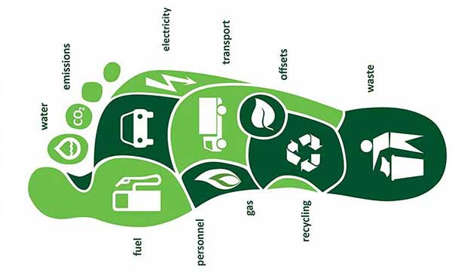

**How To Calculate Your Carbon Footprint**

[**Energy Conservation**](https://justenergy.com/blog/category/energy-conservation/)**,**[**Sustainable Energy**](https://justenergy.com/blog/category/sustainable-energy/)

**“What is a carbon footprint?” you ask.**

We all leave a mark on our planet. Think of your **carbon footprint** as your personal impact.

In technical terms, your carbon footprint is the amount of greenhouse gas you produce in units of carbon dioxide. This footprint is determined by your daily lifestyle and activities, such as travel (car, plane, train, etc), electrical use, consumption of products and services, foods you eat, etc.

As discussed in our blog on the [human causes of climate change](https://justenergy.com/blog/human-causes-of-climate-change-part-i/), **greenhouse gases** are the primary contributors to many of today’s environmental issues, including pollution, climate change, and global warming.

Top of Form

Zip CodeSee Plans

Bottom of Form

There are a number of free resources online that show how to calculate your carbon footprint, including our handy calculator, [this calculator](http://www.nature.org/greenliving/carboncalculator/index.htm) from The Nature Conservancy, or [this one](http://www.epa.gov/climatechange/ghgemissions/ind-calculator.html) from the EPA.

Alexandra Shimo-Barry, author of “The Environment Equation,” has come up with a formula that explains how to calculate your carbon footprint at home, too! Simply follow the below steps, and voila.

1. *Multiply your monthly electric bill by 105*
2. *Multiply your monthly gas bill by 105*
3. *Multiply your monthly oil bill by 113*
4. *Multiply your total yearly mileage on your car by .79*
5. *Multiply the number of flights you’ve taken in the past year (4 hours or less) by 1,100*
6. *Multiply the number of flights you’ve taken in the past year (4 hours or more) by 4,400*
7. *Add 184 if you do NOT recycle newspaper*
8. *Add 166 if you do NOT recycle aluminum and tin*
9. *Add 1-8 together for your total carbon footprint*

Keep in mind that an “ideal” carbon footprint (or a “low” footprint) is anywhere from 6,000 to 15,999 pounds per year. 16,000-22,000 is considered average. Under 6,000 is considered very low. Over 22,000? You may want to take some of these “[living green](https://justenergy.com/blog/earth-day-is-every-day-reducing-your-carbon-footprint-year-round/)” practices into consideration.

[](tel:+1-866-550-1550)

If your number is higher than you’d expect, don’t despair! There are a number of small sacrifices/measures you can make in order to lower your carbon footprint, such as [recycling](https://justenergy.com/blog/reduce-garbage-recycle-more/), utilizing [these daily tips](https://justenergy.com/blog/top-ten-tips-for-a-lower-electric-bill/), or purchasing carbon offsets.

Do you have a question or comment to add on this topic? We’d love to hear your thoughts, as well as suggestions for solutions to the problem of human causes of climate change. Let us know in the comments, below or via [Just Energy Facebook](https://www.facebook.com/JustEnergyUS/) and/or [Twitter](http://www.twitter.com/justenergygroup)!

Brought to you by [**justenergy.com**](https://justenergy.com/)